FAB MICHAELMAS TEST – PAPER 2 ANSWERS

- Write short notes on:
  - Adductor canal
From apex of femoral triangle adductor hiatus in adductor magnus. Anterior = vastus medialis, posteromedial = adductor longus, distally = adductor magnus. Roof is covered with thick layer of fascia with Sartorius lying above this. Contains femoral artery and vein.
  - Shoulder abduction
Requires supraspinatus for initiation, deltoid for abduction to 90 degrees. From here lateral rotation of the humerus is required. From 30 degrees onwards rotation of the scapula is required (serratus anterior and trapezius).
  - Interossei muscles of the hand
Palmar (PADI) – Adduct – but not the middle finger. Unipennate sometimes 4 but the interossei to the thumb may be rudimentary due to adductor pollicis
Dorsal (DAB2) – Abduct – two to the middle finger but none to the little finger and thumb as have their own abductor muscles. Bipennate.
All are supplied by the ulnar nerve.
  - Muscles controlling pronation and supination of the forearm
Pronation = pronator quadratus and pronator teres
Supination = biceps brachii and supinator
- Draw a simple diagram of:
  - Popliteal fossa
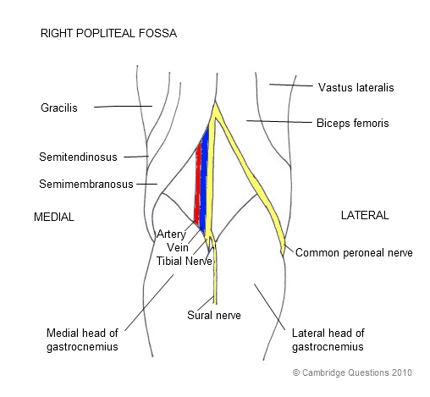
  - Anatomical snuffbox
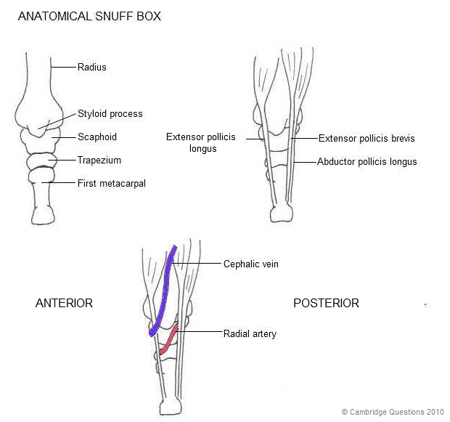
  - Humeral fractures and associated nerve/vessel injuries 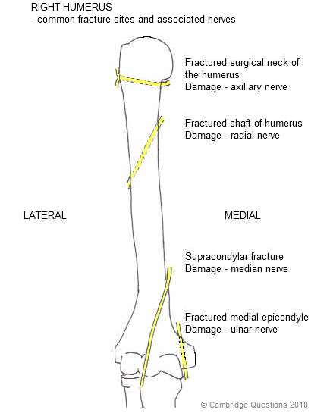
  - Peripheral sensory supply to foot
- List:
  - Muscles arising from the common flexor origin (and their insertions)
    - Pronator teres convex surface of radius
    - Flexor carpi radialis base of 2nd and 3rd metacarpals
    - Palmaris longus flexor retinaculum + palmar aponeurosis
    - Flexor carpi ulnaris pisiform base of 5th metacarpal
    - Flexor digitorum superficialis base of middle phalanx, either side
  - Short lateral rotators of hip (and their nerve supply)
    - Piriformis = S2,3
    - Superior gemellus = nerve to obturator internus
    - Obturator internus = nerve to obturator internus
    - Inferior gemellus = nerve to quadratus femoris
    - Quadratus femoris = nerve to quadratus femoris
  - Tendons passing under the extensor retinaculum (lateral to medial)
    - Abductor pollicis longus, extensor pollicis brevis
    - Extensor carpi radialis longus and brevis
    - Extensor pollicis longus
    - Extensor indicis, extensor digitorum
    - Extensor digiti minimi
    - Extensor carpi ulnaris
  - Foot bones
    - Calcanuem
    - Talus
    - Navicular (medial)
    - Cuneiforms (medial, lateral, intermediate)
    - Cuboid (lateral)
    - Metatarsals
    - Phalanges (only two of the big toe)
- Compartments (name the muscles, their nerve supply and actions):
  - Medial thigh (obturator nerve)
    - Pectineus – femoral nerve = flex hip
    - Gracilis – flex and medially rotate leg
    - Obturator externus – lateral rotator
    - Adductor longus
    - Adductor magnus – ischial head = tibial branch of sciatic nerve
    - Adductor brevis
  - Anterior leg (deep peroneal nerve)
    - Tibialis anterior dorsiflex + invert
    - Extensor hallucis longus extend hallux
    - Extensor digitorum longus extend digits
    - Fibularis tertius dorsiflexion + eversion
  - Posterior leg (tibial nerve)
    - Superficial plantarflex
      - Gastrocnemius
      - Plantaris
      - Soleus
    - Deep
      - Popliteus rotates tibia medially or femur laterally
      - Tibialis posterior plantarflex
      - Flexor hallucis longus flex hallux
      - Flexor digitorum longus flex toes
  - Anterior thigh (femoral nerve)
    - Sartorius flex hip, flex knee, laterally rotate thigh
    - Quadriceps (rectus femoris, vastus lateralis, medialis and intermedius) extend knee, rectus femoris also flexes hip
- Describe the course of:
  - The great saphenous vein
1cm anterior to the medial malleolus, ascends to pass a palms breadth posterior to the medial patella. Joins femoral vein at the sapheno-femoral junction (4cm inferior and lateral to the pubic tubercle).
  - Brachial artery
Starts at lower border of teres minor from the axillary artery. Descends in the medial bicipital furrow deep to biceps. Emerges in the cubital fossa medial to the biceps tendon. Passes deep to brachialis and divides at the level of the neck of the radius to form the ulnar and radial arteries.
  - Ulnar nerve
Medial cord of the brachial plexus C7,8,T1. Descends medial to the brachial artery. Passes posterior to the medial malleolus. Enters anterior compartment and passes between two heads of flexor carpi ulnaris. Descends and is joined by ulnar artery and together they pass through Guyon’s canal.
  - Femoral artery
From external iliac, passes beneath inguinal ligament, between nerve and vein in the femoral triangle. Gives off profunda femoral artery before descending as the SFA to run through adductor canal and eventually adductor hiatus to enter posterior compartment where it becomes the popliteal artery (which subsequently divides into anterior tibial, fibular and posterior tibial).

